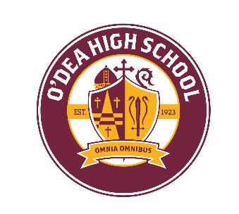
2025-2026 Summer Reading List

Required summer reading for each class is as follows:
English 12 Honors: Seattle U Matteo Ricci -- World Literature
Mr. Will Cronin - wcronin@odea.org
A Small Place, by Jamaica Kincaid
English 12: World Literature
Mr. Jackson Derby - jderby@odea.org
I Am Legend, by Richard Matheson
English 11 Honors: Seattle U Matteo Ricci - Composition
Mr. Will Cronin - wcronin@odea.org
The Boys in the Boat, by Daniel James Brown
English 11: American Literature
Mr. Wayne Carlson – wcarlson@odea.org
Friday Night Lights, by Buzz Bissinger
English 10 & 10 Honors
Mr. Wayne Carlson – wcarlson@odea.org
Mr. Will Chambers - wchambers@odea.org
The Alchemist, by Paolo Coelho
English 9 & 9 Honors
Ms. Michelle Dalida - mdalida@odea.org
The Book Thief, by Markus Zusak

